

InPlace

Faculty Liaison User Guide

Rhode Island College
Social Work



Copyright 2016 Quantum Information Technology Pty Ltd. All rights reserved.

Information in this document is subject to change without notice. The software described in this document is furnished under a license agreement or nondisclosure agreement. The software may be used or copied only in accordance with the terms of those agreements. No part of this publication may be reproduced, stored in a retrieval system, or transmitted in any form or any means electronic or mechanical, including photocopying and recording for any purpose other than the purchaser's personal use without the written permission of Quantum Information Technology Pty Ltd.

Quantum Information Technology Pty Ltd
www.Inplacesoftware.com
info@inplacesoftware.com

Faculty Liaison

Logging In
- Faculty will log into InPlace at https://ric-us.inplacesoftware.com/student/home using single Sign-On.
- Select Staff and Students option to login using your MyRic account. If you are already logged into your RIC account, you will be signed in automatically.
- In the Username field enter your credentials (If necessary).
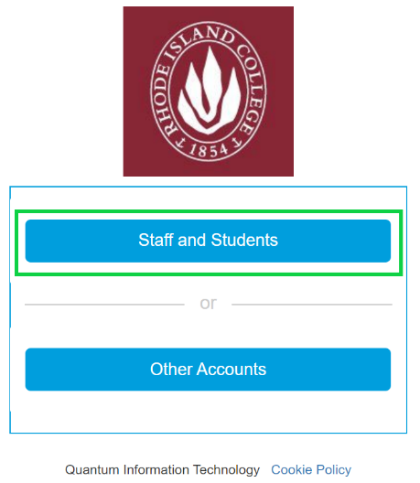

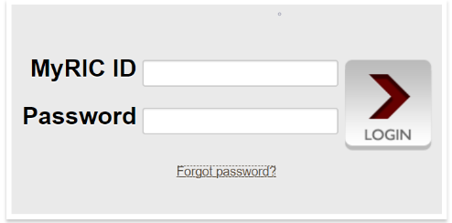

Dashboard
- You will be able to view all of the upcoming placements for your assigned students on the left side of your screen.
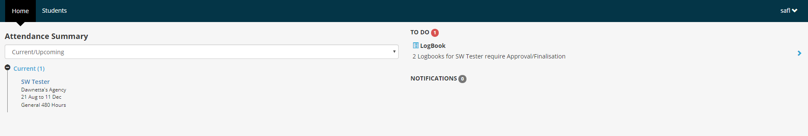
- All notifications and to do items will show on the right side of your screen e.g. logbooks and assessments

Viewing Students and their placements
- Click on Students to view all of your students and their placements.
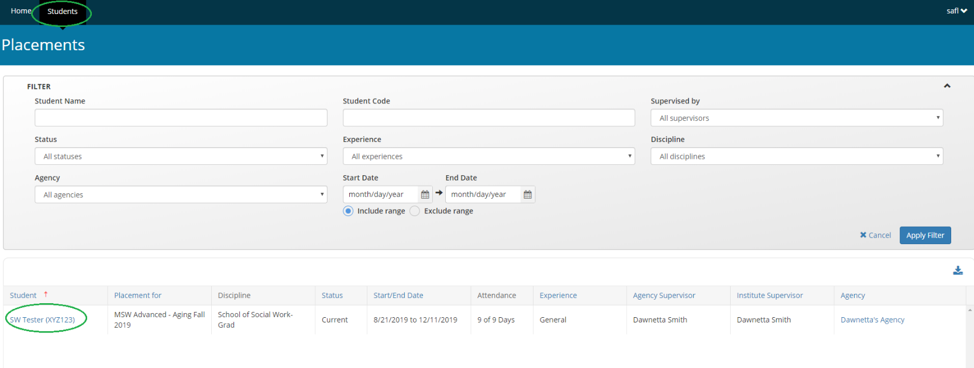

- Click on the student’s name to view their placement details.
- On the placement details you will find your student’s uploaded learning contract and date of
submission.
- You will also update their learning contract status and enter any comments. This will let the student know if anything has changed or if they need to make updates and resubmit.
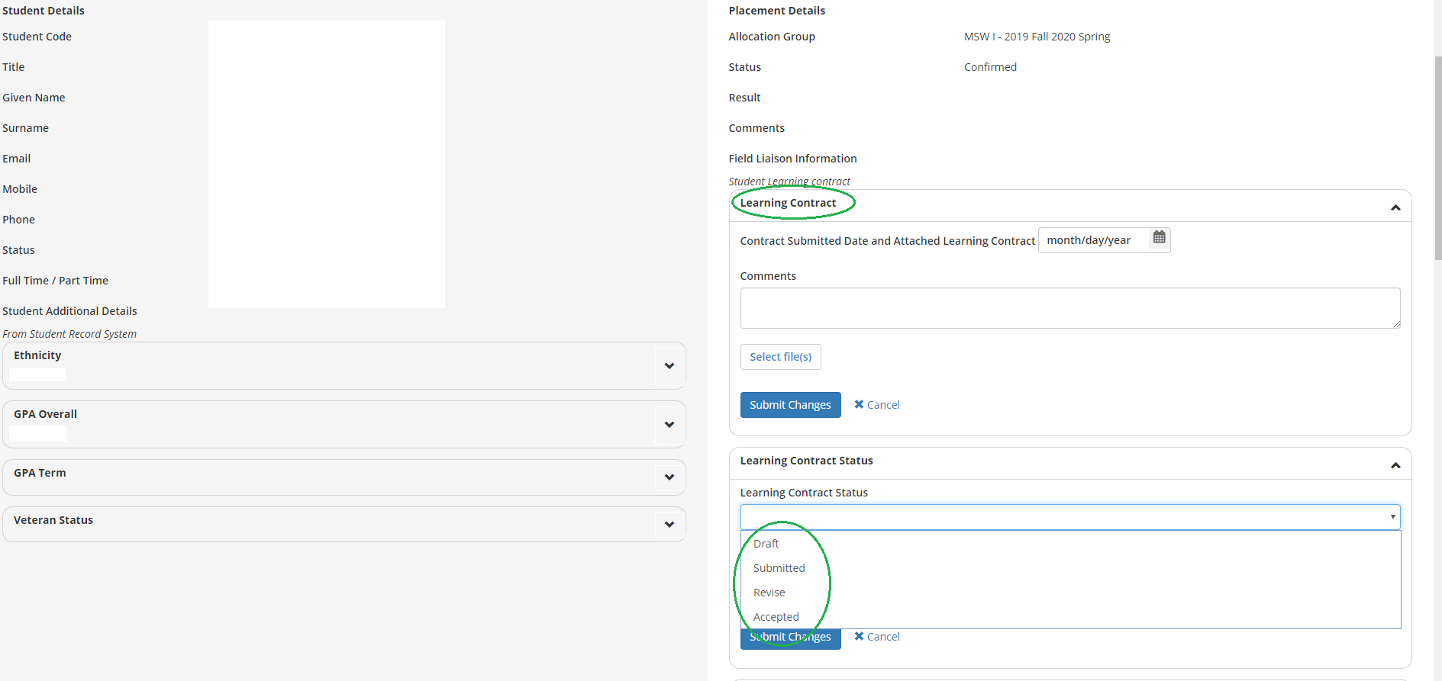

Agency Site Visit
- The Agency Site Visit form will appear on the right hand side of the placement details page.
- The first site visit is mandatory.
- Click on the arrow on the right hand side of the field to open the question.
- Click into the field to see a dropdown of your options and make your selection(s).
- Click submit.

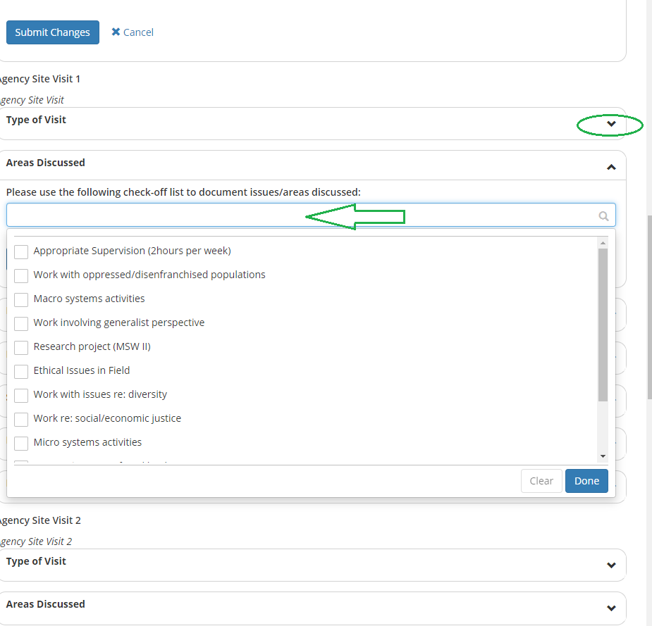

Students log their hours (optional)
- Click on the Placement Schedule Tab to view the student’s logbooks.
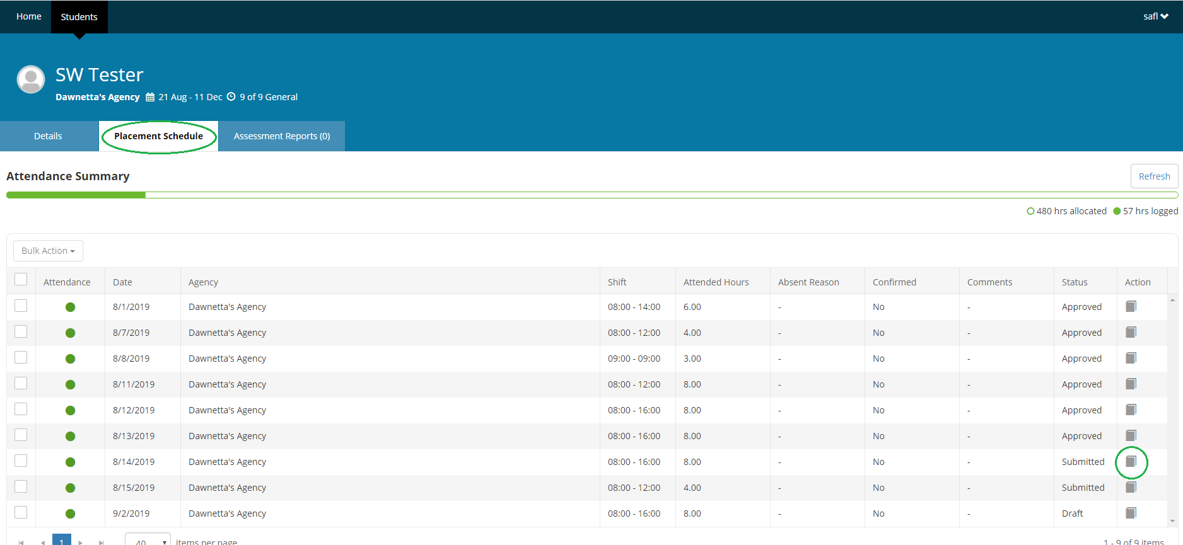
- Click on a submitted logbook to approve the student’s timesheet and weekly supervision.
- Click Approve if log looks good.
- . If you want the student to REVISE the log book enter a comment at the bottom in the supervisor comment to let them know what needs to be corrected. Then press the Revise button to send a request back to the student to revise their logbook.
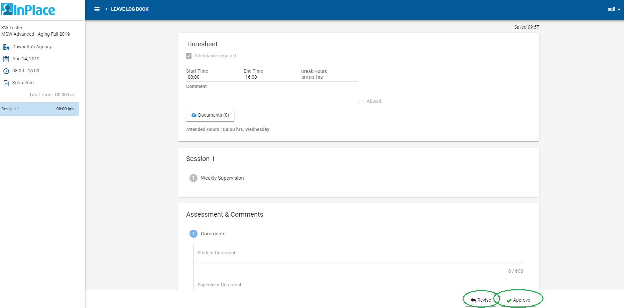

24 Hour Time Chart:

