

InPlace


Field Instructor Guide

Copyright 2016 Quantum Information Technology Pty Ltd. All rights reserved.

Information in this document is subject to change without notice. The software described in this document is furnished under a license agreement or nondisclosure agreement. The software may be used or copied only in accordance with the terms of those agreements. No part of this publication may be reproduced, stored in a retrieval system, or transmitted in any form or any means electronic or mechanical, including photocopying and recording for any purpose other than the purchaser's personal use without the written permission of Quantum Information Technology Pty Ltd.

Quantum Information Technology Pty Ltd
www.Inplacesoftware.com
info@inplacesoftware.com

Field Instructors

- Agencies users are notified by email to login to InPlace and respond to field internship requests with their username and password at https://ric-us.inplacesoftware.com
  - Note: Use the Other Accounts option to login
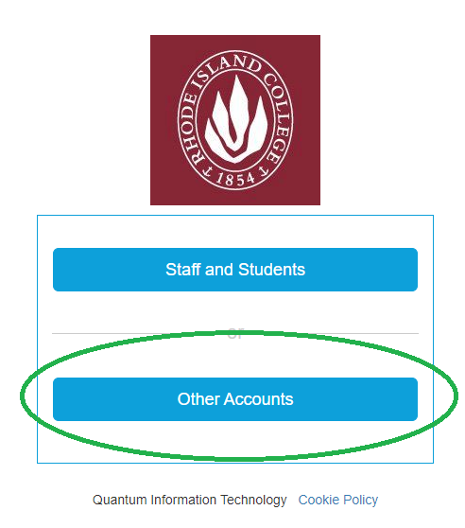
- Login and update your password and personal information by clicking on your username in the top right corner and going to My Details.
- You will see your student groups and any to do items on your login page.

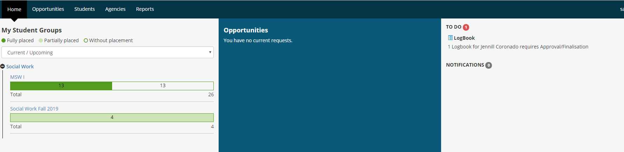

- To view placements at your agency, click on the Students tab.
- Use the filters to narrow down your search and view students and supervisors on the placements.
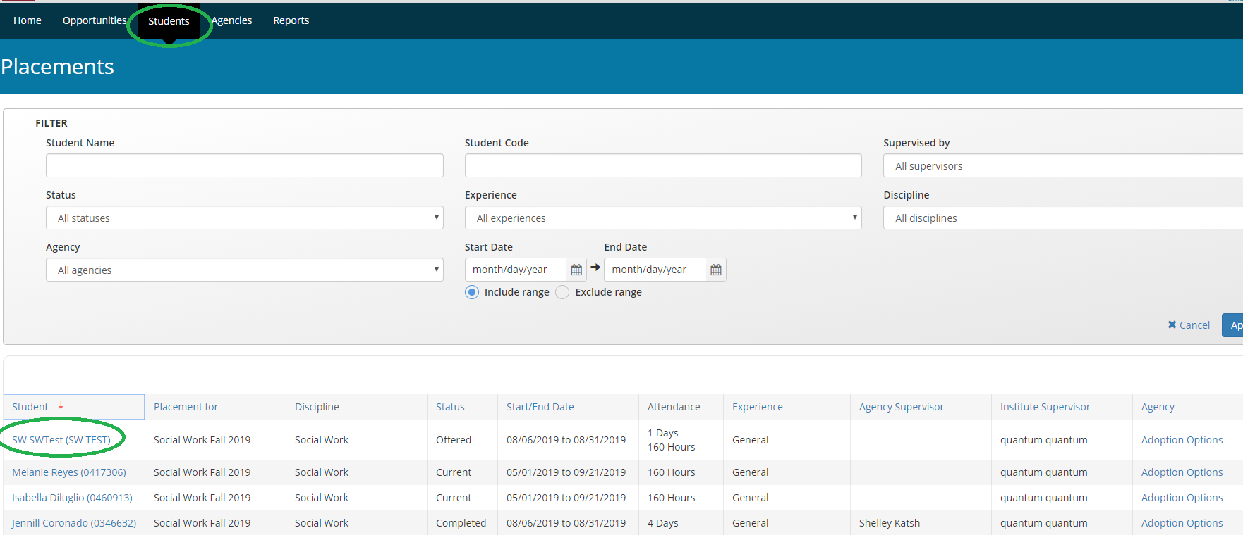

- Click on the student’s name to view their general information.
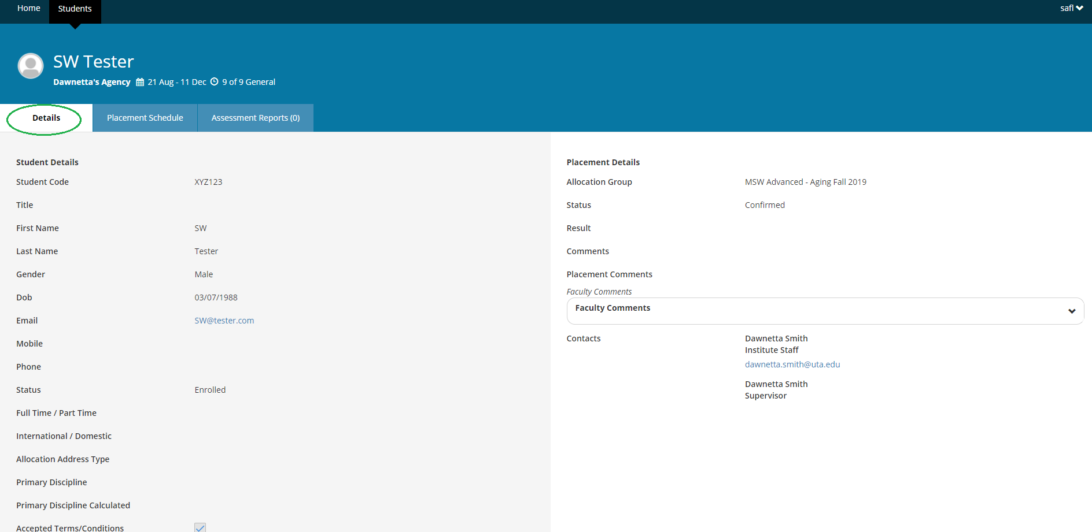

- Click on the Placement Schedule Tab to view the student’s logbooks (if using).
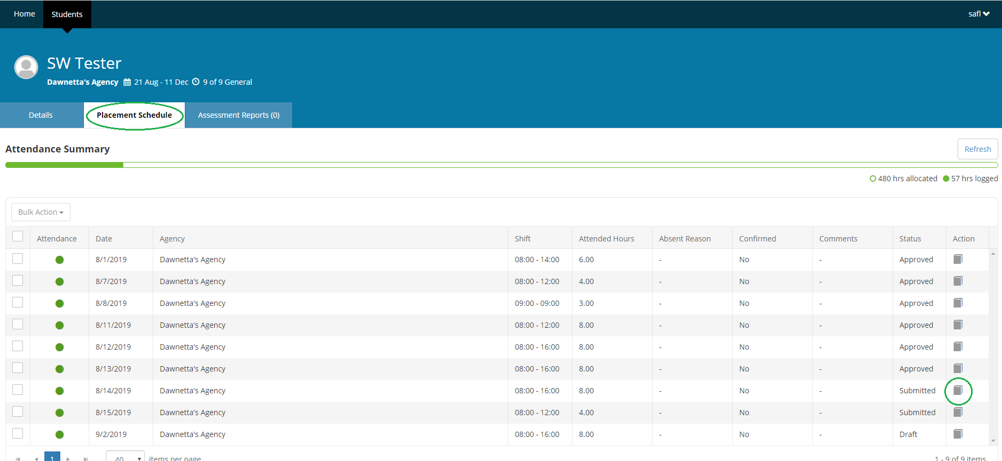
- Click on a submitted logbook to approve the student’s timesheet and weekly supervision.
- Click Approve if log looks good.
- If you want the student to REVISE the log book enter a comment at the bottom in the supervisor comment to let them know what needs to be corrected. Then press the Revise button to send a request back to the student to revise their logbook.
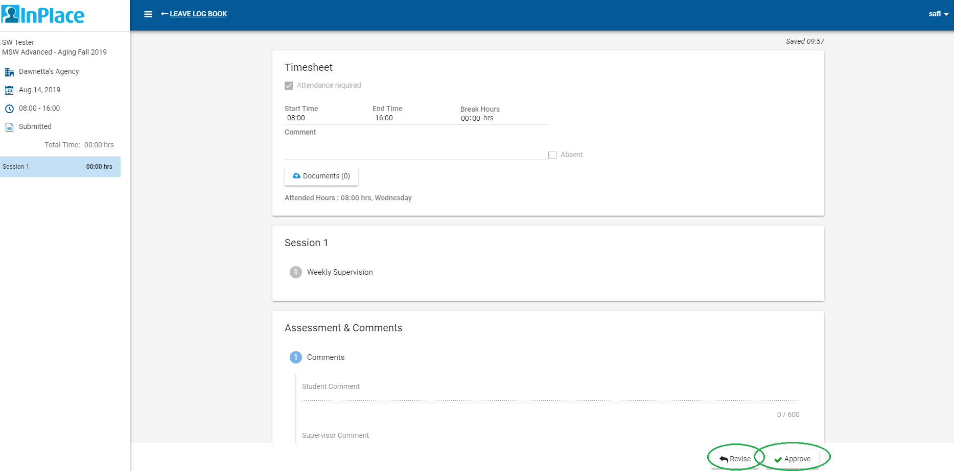

24 Hour Time Chart:

